M.C. Escher: Optical Illusions & Impossible Worlds
By: Troy Paplomatas
ETLA 350
April 3, 2017
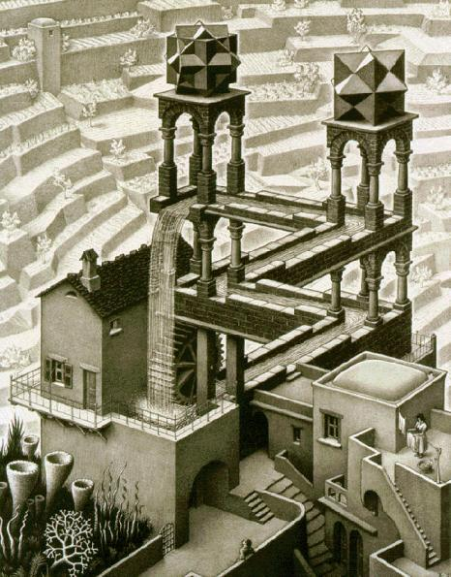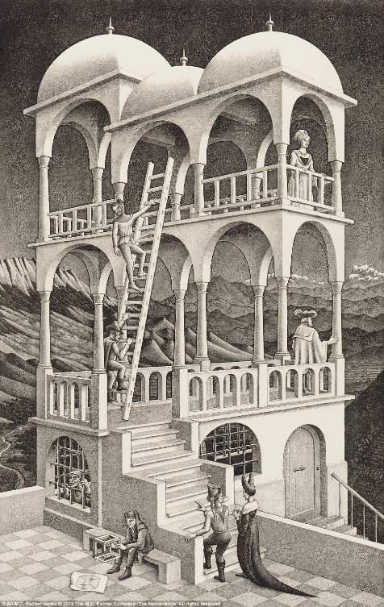

Troy Paplomatas
ETLA 350
Dr. Edmunds
March 22, 2017
M.C. Escher: Optical Illusions & Impossible Worlds
In this research paper, I will be discussing the art works of M.C. Escher that consist of optical illusions and impossible worlds. To do so, I will describing four of his most popular works when he implemented optical illusions and also creating impossible worlds: Drawing Hands (1948), Waterfall (1961), Belvedere (1958), and Ascending and Descending (1960). Each of these pieces represent Escher’s interest in creation artwork that depicted illusions and impossible worlds. A short background on Escher, "Maurutus Cornelis Escher was born in Leeuwarden in 1898, the youngest son of a hydraulic engineer, G.A. Escher. G.A. Escher believed his son should have ought to be a given a sound scientific training and that the most suitable plan for the boy to aim at for after all, he was really quite gifted artistically-would be to become an architect. However, Maurtis's architectural training did not last long once he heard a lecture given by Samuel Jesserun de Mesquita on graphic techniques," Ernst (Page 11) This led to M.C. Escher's love for graphic arts, which would eventually lead to his interest implementation of mathematical artwork. However, Escher did not consider himself a mathematician. Many of M.C. Escher’s works were created with the implementation of optical illusions and impossible objects. Starting with his piece, Drawing Hands (1948) Escher began implementing optical illusion effects. “A Perception, as of visual stimuli (optical illusion) that represents what is perceived in a way different from the way it is in reality,” (Dictionary.com) Illusions provide an image that is deceiving to the human eye and physically impossible to construct, artists take advantage of the psychological aspects. “Optical illusions, one of mankind’s gifts to us, dates back to 5th century B.C. It was a time of discovery where the surroundings where still viewed as a mystery, waiting to be solved. One mystery was of the unexplainable optical illusions that existed during that time. Epicharmus, a Greek philosopher, was the first one to provide an answer for it,” (Opticalspy.com) M.C. Escher created many pieces of art with the focus on optical illusions. Escher often found interest in creating art with illusion perspective and creating his, “impossible world” pieces. This research paper will consist of M.C. Escher’s art work where optical illusions and impossible worlds have been implemented and apply observations of the illusions of the art work.
The most basic illusion for the human eye to be deceived is a drawing of a cube. ”Two-dimensional drawings (on a flat surface) can be made to convey an illusion of three dimensional reality. Usually this deception is employed to depict realistic, solid objects in spatial relationships achievable in our world of sensory experience,” (Simanek 1996) A group of three dimensional objects like cubes, aligned and adjusted to a certain degree, can portray an impossible figure which produces an illusion. As the object may seem to be rational, the object can never truly be created due to not being mathematically possible. “The conventions of classical perspective are very effective at simulating such reality, permitting 'photographic' representation of nature. This representation is incomplete in several ways. It does not allow us to see the scene from different vantage points, to walk into it, or to view objects from all sides,” (Simanek 1996) Flat paintings or drawings are what make up a majority of impossible figures due to the inability to physically construct these figures. M.C. Escher portrayed impossible objects as mathematical equations that can only be solved and portrayed correctly through applying them to art.
One of Escher’s first pieces that consisted of an illusion was, Drawing Hands (1948). This piece is a very simple drawing that is quite deceiving to the human eye. Escher’s
Drawing Hands (1948), is a piece of two hands drawing one another that seems to be coming out of the page. The right hand is drawing the left and the left is drawing the right. Even though this is somewhat of a basic piece for Escher, it still tricks the viewer’s perception of the piece. What makes the piece look to be so real is the fact that it is a drawing of a drawing. The landscape the hands are being drawn on is within the piece, turning it into a sketch of a sketch. By doing so, Escher helps the perception of the piece to be coming out of the paper. “Those visions fed what would become Escher’s most celebrated works. In 1948, he made Drawing Hands, the image of two hands, each drawing the other with a pencil. It is a neat depiction of one of Escher’s enduring fascinations: the contrast between the two-dimensional flatness of a sheet of paper and the illusion of three-dimensional volume that can be created with certain marks. In Drawing Hands, space and the flat plane coexist, each born from and returning to the other, the black magic of the artistic illusion made creepily manifest,” (Poole 2015) M.C. Escher knew how to implement illusions to create a piece that the audience can contemplate whether or not the image is a legitimate object. Escher’s goal was to create images that are three-dimensionally impossible to physically construct, but can be transformed into a two-dimensional surface.
In 1961, M.C. Escher created the lithograph, Waterfall (1961) which was created with the intentions of creating an illusion. The piece’s large structure resembles a living compound of some sort with the focus on the walk-way that is created by an illusion. The center of the piece is where the optical illusion takes place where Escher created a brick structure that is deceiving to the eye. The structure looks to be a walk-way that turns right to left. The deceiving part of the walk-way is at each corner, there are four columns that look to be holding up the other corner of the walk-way. As it has a natural presence to the structure, the structure itself is physically impossible to create due to the columns not connecting directly from top to bottom. “If it could work, this would be the ultimate perpetual motion machine that also delivers power! If we look closely, we see that Mr. Escher has deceived us, and any attempt to build this structure using solid masonry bricks would fail,” (Simanek 1996) Not only is the structure physical impossible, on top of the two top columns there are two impossible figures created by Escher. You could argue, that Escher added the two impossible objects just to justify that the columns that are beneath the objects are holding up the impossible objects. This piece has been used for examples of optical illusions many times due to the piece’s natural appearance. Escher wanted to create an image that is perceived to be a natural construction that still tricks the human eye.
Another piece by Escher that interpreted an impossible world is, Belvedere (1958). Belvedere is a certain type of architectural design that is primarily used for a good viewpoint. Usually on top of structures, belvederes consist of high columns and high ceilings to acquire a broad viewpoint. In M.C. Escher’s piece, Belvedere (1958) he focused on the alignment of the columns and connected them in a way to which is impossible to construct. Also, Escher created a two story belvedere and designed the top roof to be turned 180 degrees from the bottom floor’s ceiling. At first glance, the building does not seem to be constructed in a way that is different. However, once you start to focus on the columns, you realize the columns are not aligned properly. Escher realized if he could change the perspective of the building, the object as a whole looks well-constructed. However, the overall construction itself is physically impossible to create due to Escher’s application of impossibility. For mathematicians like Escher, figures like Belvedere (1958) created an entire math problem itself and brought a lot of attention to mathematicians and scientists. “It may be that the appreciation of such visual paradoxes is one sign of that kind of creativity possessed by the best mathematicians, scientists and artists. M. C. Escher's artistic output included many illusion pictures and highly geometric pictures, which some might dismiss as `intellectual mathematical games' rather than art. But they hold a special fascination for mathematicians and scientists,” (Simanek 1996) Belvedere (1958) is a piece that has visually reasonable appearance, but a mathematically impossible construction. Creating an impossible figure and optical illusion all in one piece of art.
Ascending and Descending (1960), was another impossible figure piece created by M.C. Escher in 1960, only two years after he complete Belvedere (1958). This piece is focused on the staircase that is on top of the building. The interesting thing about this staircase is that it is ascending and descending in a square path. The building itself seems to be a well-constructed building with emphasis on the staircase at the top. For the staircase itself, all sides are not the same in length. Each set of stairs are different in length and have a different number of steps. This is where Escher applied different perspectives. ” This could be drawn with vanishing points in full perspective. M. C. Escher, in his 1960 lithograph Ascending and Descending (1960), (above) chose to construct the deception in a different manner. He placed the staircase on the roof of a building and structured the building below to convey an impression of conformity to strong (but inconsistent!) vanishing points. He has the right vanishing point higher than the left one,” (Simanek 1996) Escher focused on how he could manipulate his work to trick the human eye and mind with illusions and different perspectives. Many people look at illusions and are not at all intrigued. Their response may be, “Just a mis-made picture,” or “you’re just looking at it wrong.” Escher wanted to create images that had big emphasis on illusions but did not want to focus the entire image on illusion. Pieces like Ascending and Descending (1960), only having one piece of the image where it is an illusion, where the rest of the image does not focus on any type of illusions. Escher wanted to focus on one certain space of the piece to where the audience will show attention to immediately. Escher’s goal was to grab the eye on the viewer and focus on the illusion aspects of the piece.
M.C. Escher was known for his use of mathematical art that often perceived impossible objects and worlds. Applying his mathematics skills, Escher was able to successfully create art pieces that were deceiving to the viewer’s perspective. Impossible worlds and illusions like and Drawing Hands (1948), Belvedere (1958), Ascending and Descending (1960), and Waterfall (1961), are all pieces of art that depict illusions and an impossible worlds that M.C. Escher created with the use of mathematics. Beginning with Drawing Hands (1948), Escher began his impossible world ideas when he created this interesting piece. The simple idea of hands drawing each other, to be challenged or questioned was made possible by the illusion that Escher created. Escher’s Belvedere (1958), is arguably his most famous piece. In this piece, Escher created an optical illusion that is noticed as soon as the human eye views it. The fact that both stories of the Belvedere 1958) are not laid out in the same direction, but they are connected by columns, creates an impossible construction and an optical illusion. The never-ending staircase in his piece, Ascending and Descending (1960), is another creation of an impossible object by Escher. This impossible world is deceiving due to each set of stairs seem to be level while they’re ascending or descending. Again, impossible to physically construct, but Escher wanted to create an impossible object on a two dimensional surface. The last piece discussed in this paper is Waterfall (1961), which was another piece depicting an impossible world and an optical illusion. Similar to Belvedere (1958), the impossible world aspects of Waterfall (1961) are depicted by the columns in the construction and illusion of the columns. M.C. Escher is famous for his mathematical art, illusions, impossible worlds, and change of perspective. Each of Escher’s pieces; Drawing Hands (1948), Belvedere (1958), Ascending and Descending (1960), and Waterfall (1961), are all examples of Escher most famous impossible worlds and optical illusion artwork. All in all, Many of M.C. Escher’s works were created with the implementation of deceiving the human eye into seeing something that should not belong.

Work Cited
Simanek, Donald E. “The Principles of Artistic Illusions.” The Principles of Artistic Illusions. N.p., n.d. Web. 27 Feb. 2017
Poole, Steven. “The Impossible World of MC Escher.” The Guardian. Guardian News and Media, 20 June 2015. Web. 27 Feb. 2017
Illusion. (n.d.). Dictionary.com Unabridged. From Dictionary.com website Retrieved
February 26, 2017
“Mathematical Art of M.C. Escher.” Mathematical Art of M.C. Escher – Impossible World. N.p., n.d. Web. 27 Feb 2017

